Remove Dynamic Wifi Setting

Version Control:

Use Case Name: |  | Remove Dynamic wifi Setting
Use Case Owner: |  | Sumit Borade
Current Version |  | 0.1
Use Case Version History
Modified Date | Version |  | Modified By | Change Description
August 26,2009 | 0.1 |  | Sumit Borade | Initial Version

Brief Description:
This use case describes the process by which a YouSee subscriber orders a change to their broadband services and how the service is changed.

The use case is written from the perspective of the SMP provisioning solution.

Related Documents
- YouSee SMP SOW2Architecture Requirements Document
- YouSee SMP SOW2 Business Requirements Document
- Voice over Cable Use Case Activation
- Cisco BACC TC Specification

Related Use Cases

Pre-Conditions
- Subscriber has a WIFI capable Cable Modem but he does not wants to use the Package for WIFI

Post-Conditions
- Subscriber is not able to use WIFI internet on his WIFI Cable Modem.

Use Case

Primary Flow Diagram
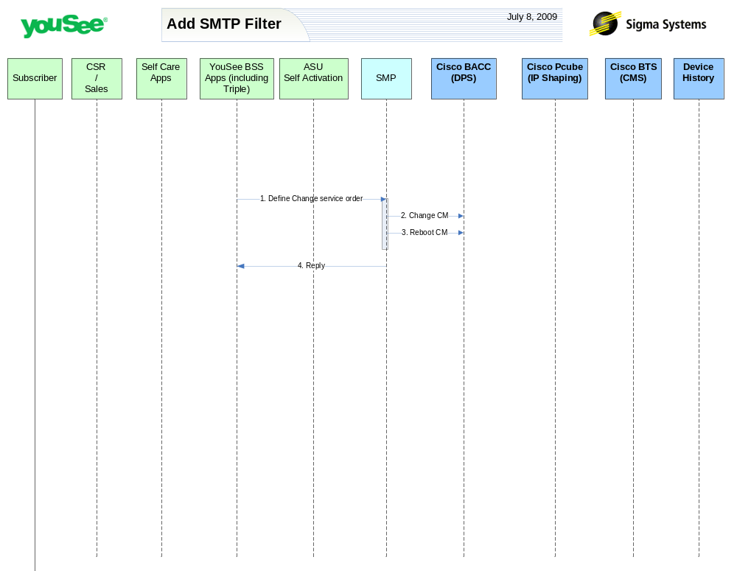

Primary Flow Detail
# | Actor: Key Action | Description | Alternate Flows/Details
 | YouSee BSS: Order is communicated to SMP to Set dynamic wifi settings. | YouSee BSS (Triple) will communicate the order to SMP through SMP’s OSS/J Order Management API. Triple will provide logical services and service attributes. SMP will be required to translate these service/service attributes to engineering level resources and resource attributes.
 | SMP: modifies CM in BACC | SMP will change the configuration of the CM in BACC.  SMP will remove following Dynamic wifi settings on BACC:-  - SSID  - PSK  - channel
 | SMP: requests BACC to reboot the CM Device | SMP will then request BACC to reboot the CM device resulting in the CM getting the new configuration, MTA to go offline and CPE to be assigned a new public IP Address.
 | SMP: Replies back to ASU the status of Activation | SMP will reply to ASU the status of Provisioning Order to ASU. | If Provisioning fails then SMP will put the Failed task in Manual Queue.

